Programming For Arduino
Lets start our tutorial on Arduino programming by looking at the most trivial Arduino program. From the Arduino IDE, just select file-->new to see a bare minimum sketch.
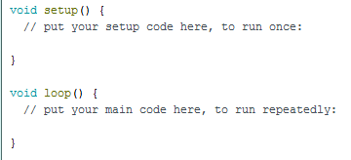

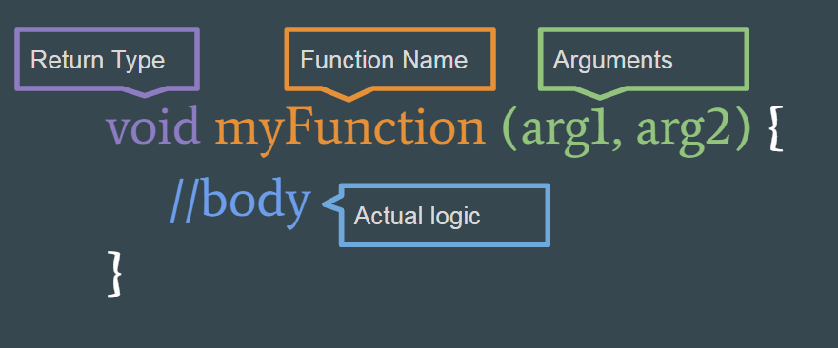
There are two main parts to any Arduino sketch: setup and loop. Each of these blocks of code is a programming construct known as a function. A function in a C-syntax language like Arduino has the following structure:

Return Type – The type of object that the function outputs. This could be something like a number or a string of text. It's very common for the return type to be 'void' which means this function doesn't actually output anything, and that's perfectly valid.
Function Name – This is just a word that describes what the function does. It can be pretty much anything you choose, but its best to try and pick a name that succintly describes what the function actually does.
Arguments – These are the inputs to the function. There can be any number of them, including zero. In the event there are no inputs, you will just see the open and close parens ( ) with nothing inside, and this is a very common case.
Body/Logic - This is the code that actually implements logic to do something. You'll notice that the body of the function is wrapper inside curly braces { } and this is important to mark the start and end of the function.
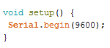
Lets look at the setup function from the blank sketch we loaded. First, we see that the return type is void, meaning this function doesn't return any data. Next, we see that the function is named setup. Next, we see that the function does not take any input arguments. And finally we see that the fuction's body is empty. It does contain a comment (a bit of text with the // symbol in front of it); but this is ignored by the compiler.
The function setup is aptly named, because (as the comment indicates) whatever code we write into the fucntion will be executed just once when the Arduino first starts up. By contrast, the second function called loop, which again return void, has no arguments, and has an empty body, get run continuously over and over while the Arduino is running.
Now lets write some code of our own into this sketch. We're going to write a program that adds together two randomly generates numbers, and prints the results to the serial monitor. We'll start by writing the following piece of code into the setup function to start Serial communications. We'll need this so we can actually see the results of our code.

Now we're going to do something new: declare a variable. A variable is a contruct where we can save some value to memory and recall it later. The declaration of a variable has the following structure:
type variableName = value;

Type can be a difficult concept for first time programmers. When we assign a varaible to memeory, we do so in the context of what type of data we are storing.

